Lab 10: Implementing Tkinter (GUI Basics) - Part 2
Working with Widgets through a Real-Time Billing System Case Study
Course/Lab | Artificial Intelligence / Python Programming Lab
Lab Topic | Tkinter GUI Widgets: Label, Entry, Button and Text

1. Lab Learning Outcomes
- Understand the purpose of Tkinter widgets in a graphical user interface.
- Create and arrange Label, Entry, Button, Frame and Text widgets using pack() and grid().
- Retrieve, validate, delete and display user input using Entry and Text widgets.
- Connect buttons with functions using the command property.
- Develop a small real-time desktop application with proper comments and validation.
Real-Time Scenario
Case Study Task: Mini Cafe Billing System
A local cafe owner wants to improve the daily counter sales process by using a simple computerized billing system instead of manual calculation. The cafe sells common items such as Tea, Coffee, Sandwich, Burger, Fries, and Juice. During daily operations, the cashier needs to quickly enter customer details, select or enter the purchased item, add the item price, quantity, and apply an optional discount if required.
Students are required to modify the given Tkinter billing application into a Cafe Billing System. The updated application should allow the cashier to enter the customer’s name, contact number, selected cafe item, item price, quantity, and discount percentage. The system must validate all input fields before generating the bill. For example, customer name should not be empty, contact numbers should be valid, price and quantity should be numeric, and discount should not be negative.
After successful validation, the application should calculate the subtotal, discount amount, and final payable amount. It should then generate a professional receipt showing the cafe name, customer details, item details, quantity, price, discount, total amount, and a thank-you message. Students should also add buttons such as Generate Receipt, Clear, and Exit to make the application more practical and user-friendly.

2. Background: Tkinter Widgets
Widgets are the basic building blocks of a Tkinter GUI. Each widget performs a specific user-interface task, such as displaying text, taking input, or triggering an action. In this lab, students will use the following widgets in a complete working application.
Widget | Purpose | Example Use in This Lab
Label | Displays text that the user cannot edit. | Application title, form labels and receipt heading.
Entry | Accepts one-line input from the user. | Customer name, item price, quantity and discount fields.
Button | Runs a function when clicked. | Calculate Bill, Clear and Exit buttons.
Frame | Groups related widgets together. | Input form and button area.
Text | Displays or accepts multi-line text. | Generated receipt output area.
messagebox | Shows alerts or confirmation messages. | Input error messages and exit confirmation.

3. Key Tkinter Concepts Used
- Creating a Label: tk.Label(root, text="Hello") creates a display-only text element.
- Creating an Entry: tk.Entry(root) creates a text box for user input.
- Reading Input: entry.get () retrieves the value entered by the user.
- Deleting Input: entry. delete(0, tk.END) clears the Entry field.
- Button Action: command=function_name connects a button click to a Python function.
- Layout Management: pack () and grid() arrange widgets inside a window or frame.

5. Complete Code for Cafe
Click on the link to download the file code:
https://drive.google.com/file/d/1E0fZx3bLUIF4GI2Mw6dJzm4scyIVUA5T/view?usp=drive_link

Screenshot 1: Application window before input
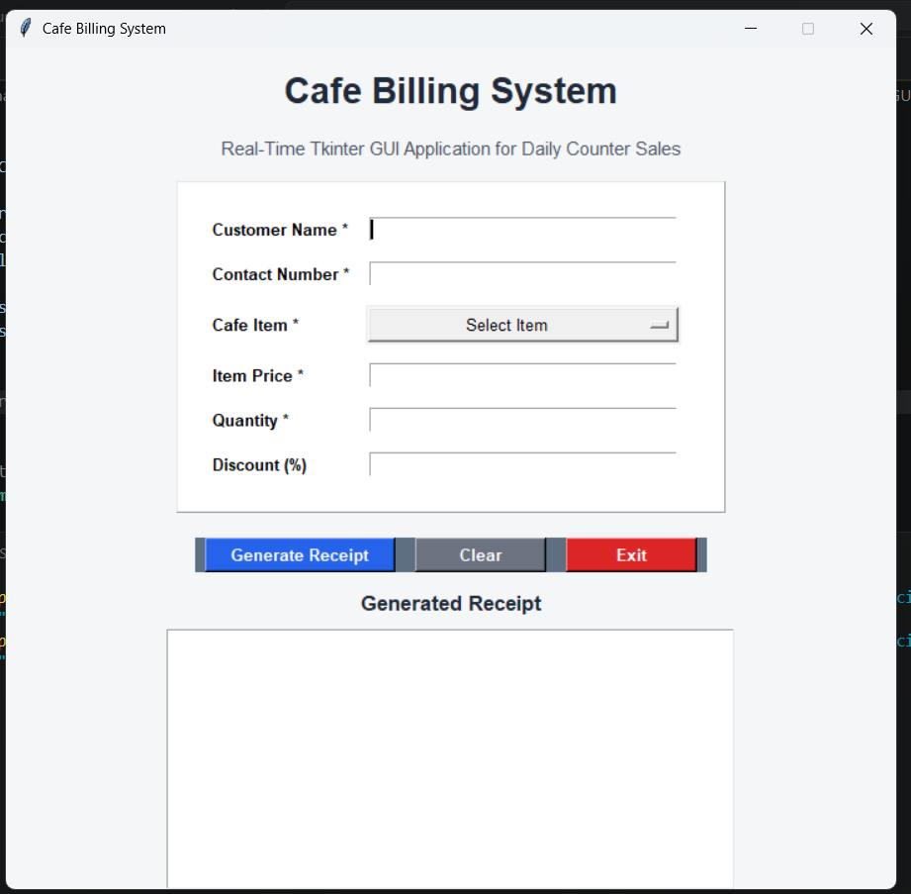

Screenshot 3: Application after calculation
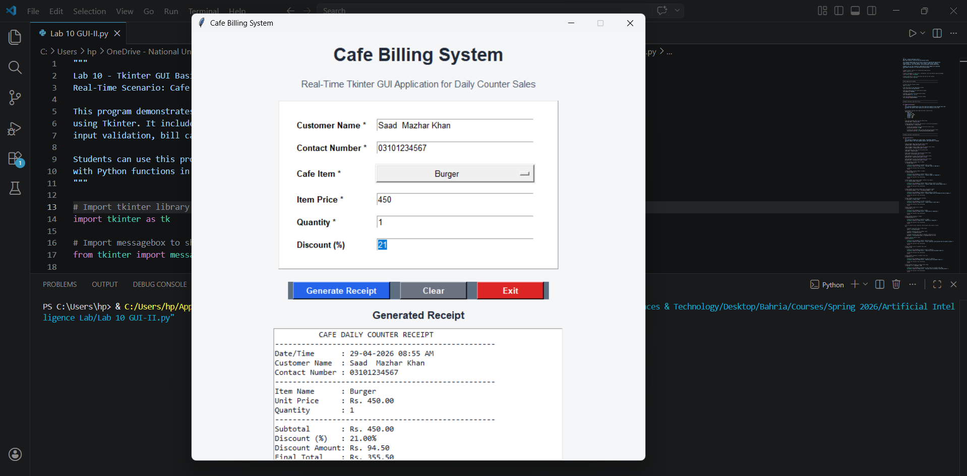

Screenshot 3: Input validation error

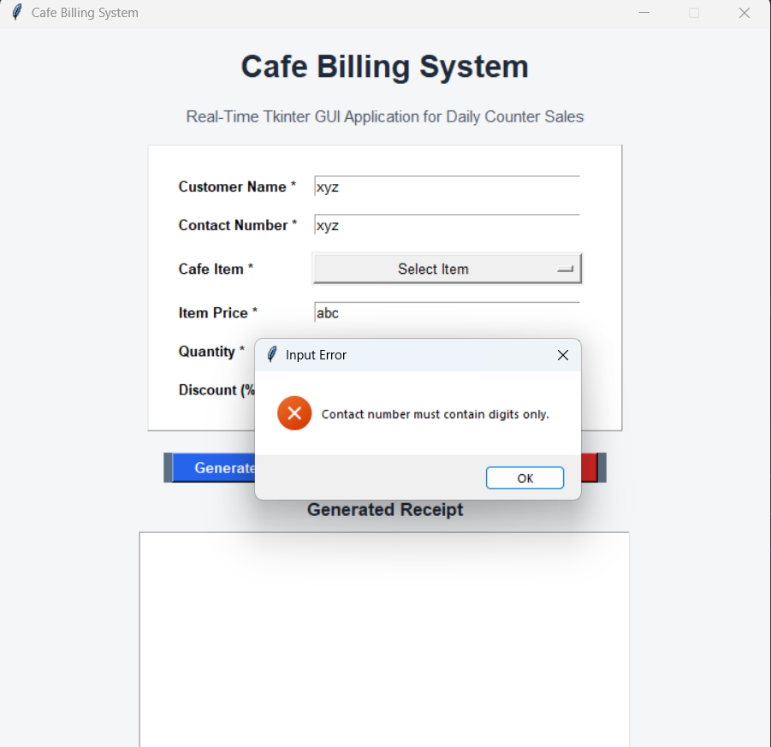

7. Student Task

Smart Billing System with AI-Based Decision Rules
In this task, students are required to extend the given Tkinter-based billing application into a more intelligent and practical system by incorporating basic AI-inspired decision-making. Instead of relying entirely on manual input, the system should simulate a real-world billing environment where certain decisions are handled automatically.
Students will design and implement a Smart Billing System for a real-world scenario such as a grocery store or retail shop. The application should allow the user to enter relevant details such as customer name, contact number, selected item from a predefined list, and quantity. The system must ensure proper input validation, including checking for empty fields, verifying numeric inputs, and ensuring valid formats for customer information.
In addition to basic billing functionality, students must integrate rule-based intelligent logic to simulate simple AI behavior. This includes automatically applying discounts based on predefined conditions such as total purchase amount or quantity, and optionally suggesting related items based on the selected product. These rule-based decisions represent a foundational approach to artificial intelligence, where the system responds dynamically based on input conditions.
After processing the input and applying intelligent rules, the system should calculate the subtotal, discount amount, and final payable amount. A structured and professional receipt should then be generated, displaying customer details, item information, applied rules (such as discount), and the final bill. The application should also include essential usability features such as clear/reset functionality and exit confirmation.

Requirement | Description
GUI Design | Create a neat Tkinter interface using Label, Entry, Button, Frame and Text widgets.
Input Validation | Ensure required fields are filled and numeric fields contain valid values.
Billing Logic | Calculate subtotal, discount, tax and final total correctly.
Receipt Generation | Display a clean receipt in the Text widget with customer and item details.
Professional Feature | Add at least one feature such as Clear, Exit confirmation, date/time display, or Save Receipt option.
Code Quality | Use meaningful variable names, indentation and proper comments.

